**DAILY ONLINE ACTIVITIES SUMMARY**

|  |  |  |  |  |  |  |  |  |
| --- | --- | --- | --- | --- | --- | --- | --- | --- |
| **Date:** | **18/06/2020** | | | | | **Name:** | **RITIKA R KULKARNI** | |
| **Sem& Sec** | **4​th​ SEM. & ‘B’ SEC.** | | | | | **USN:** | **4AL19CS403** | |
| **Online Test Summary** | | | | | | | | |
| **Subject** | | **- -** | | | | | | |
| **Max. Marks** | | **--** | | **Score** | | | **- -** | |
| **Certification Course Summary** | | | | | | | | |
| **Course** | **INTRODUCTION OF CLOUD** | | | | | | | |
| **Certificate Provider** | | | **Cognitive class** | | **Duration** | | | **5 Hrs.** |
| **Coding Challenges** | | | | | | | | |
| **Problem Statement:**   1. **A magic number is defined as a number which can be expressed as a power of 5 or sum of unique powers of 5. First few magic numbers are 5, 25, 30(5 + 25), 125,**   **130(125 + 5), ….**  **Input: n = 1**  **Output: 5**  **Input: n = 2**  **Output: 5 25**  **Input: n = 3**  **Output: 5 25 30**  **Input: n = 8**  **Output: 5 25 30 125 130 150 155 625** | | | | | | | | |
| **Status:Executed.** | | | | | | | | |
| **Uploaded the report in Github** | | | | | **Yes** | | | |
| **If yes Repository name** | | | | | <https://github.com/ritikakulkarni> | | | |
| **Uploaded the report in slack** | | | | | **Yes** | | | |

**Online Test Summary:**No internals conducted.

**Online Certification course Summary​:Today, I went through the Evolution of Cloud Computing Benefits of cloud options.**

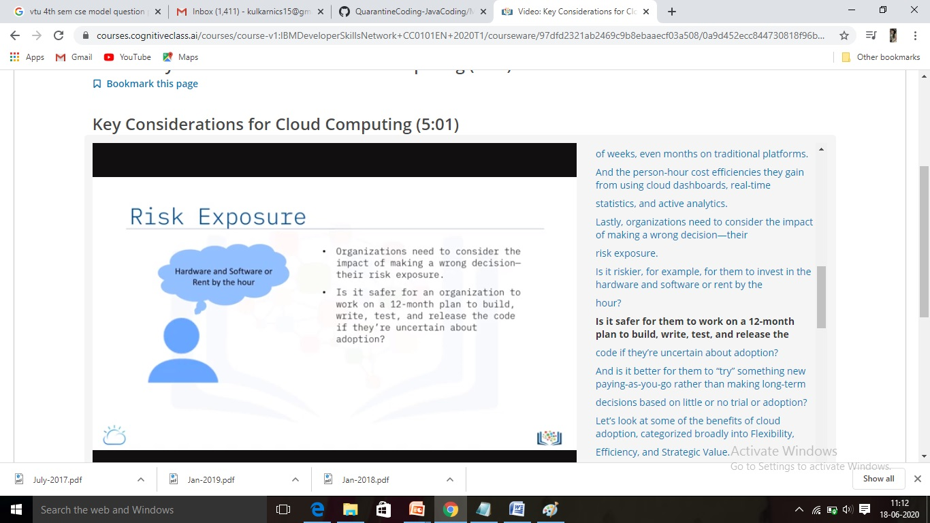

**Online Coding Summary​:Today I received one programs from prof. Venkatesh Bhat CSE Dept.. I have written one program and uploaded it to my Github repository. This is my repository snapshot. I have uploaded the frequency program.**

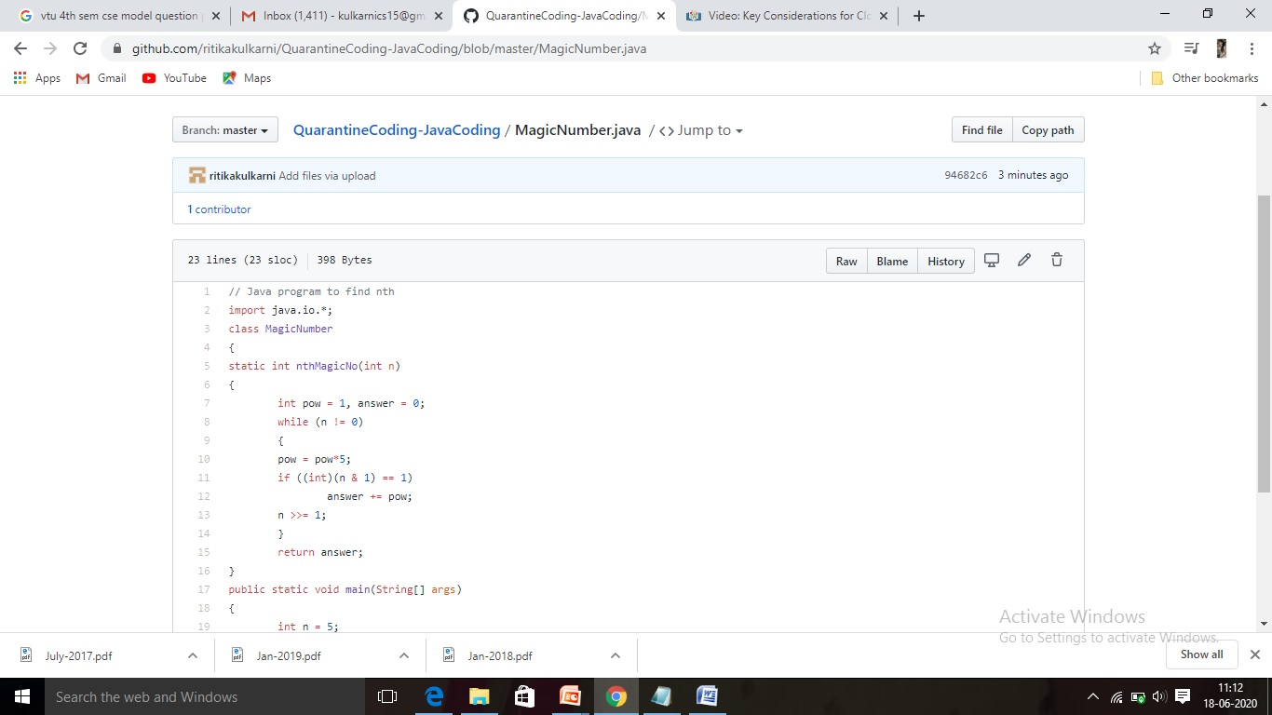

**Thank you**